Experiment:14 Date:1/08/2027

To Implement the Decision Tree Algorithm

Aim
To develop a Python program to implement the Decision Tree Algorithm for classifying data based on user-provided features and predicting the corresponding output.

Algorithm (Decision Tree)
- Read the number of training records.
- Read the feature values and class labels.
- Build a Decision Tree model using the training data.
- Read the test data from the user.
- Predict the class label using the trained model.
- Display the predicted result.

PROGRAM:

from sklearn.tree import DecisionTreeClassifier

n = int(input("Enter Number of Training Records: "))

X = []
Y = []
print("\nEnter Training Data")
for i in range(n):
a = int(input("Feature 1: "))
b = int(input("Feature 2: "))
c = input("Class Label: ")
X.append([a, b])
Y.append(c)

model = DecisionTreeClassifier()

model.fit(X, Y)

print("\nEnter Test Data")

t1 = int(input("Feature 1: "))
t2 = int(input("Feature 2: "))
result = model.predict([[t1, t2]])
print("\nPrediction =", result[0])

OUTPUT:

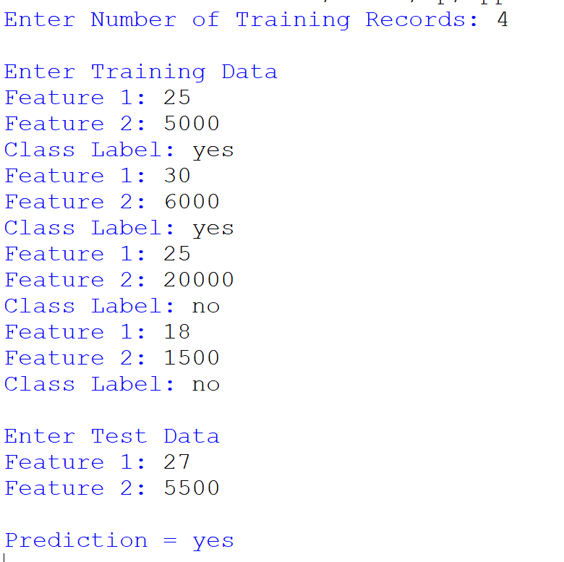

Results:
Thus, the Decision Tree Algorithm was implemented successfully, and the class label for the given test data was predicted correctly.

